WEEK-3

1. **Create a class customer with name, address as its member variables. In list of account holder’s information, find the account holder how live nearby (using pincodes).  If a name of the person is given then, customers of the same bank lives nearby should be given as output.**

**Code-**

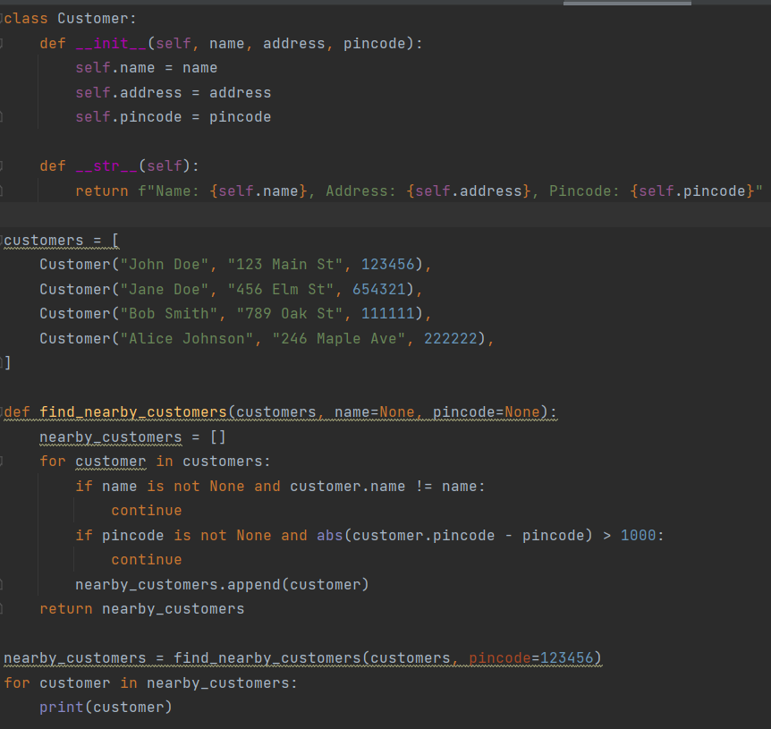

**Output-**

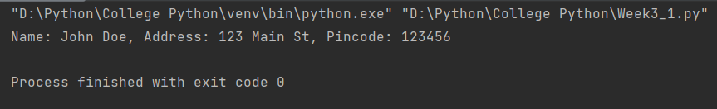

1. **Create a class that can calculate the IT the based on the loan and saving account transactions by the customer (Take the total amount deposited through out the year in an array, check the transaction which leads to saving in the same bank or other modes. Deduct the expenditure on saving to the maximum of 1.5L. For the rest of the amount calculate 6% of IT till 10L and  8% till 15L above that make 10% as IT).**

**Code-**

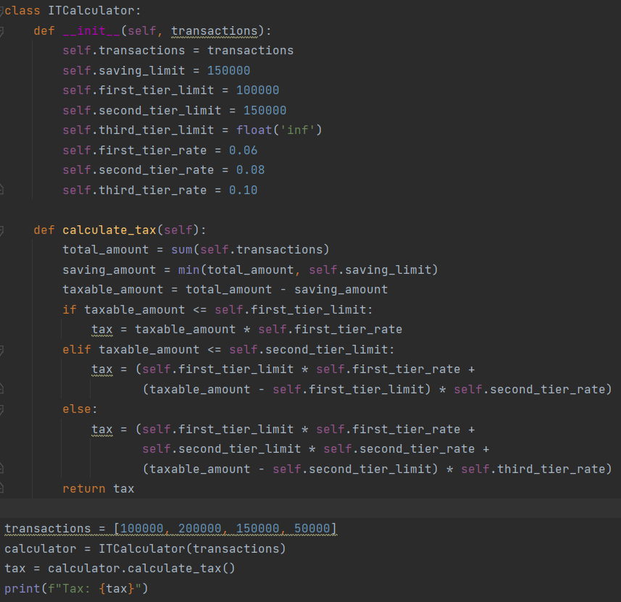

**Output-**

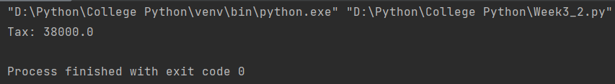

1. **Implement the following scenario using Inheritance. Create a class bank make appropriate variables, assign customer class as child of bank. Create classes Saving and Loan and Current account. Make all these classes as child of bank.  Maintain transaction function in all these class to track the tractions.**

**Code-**

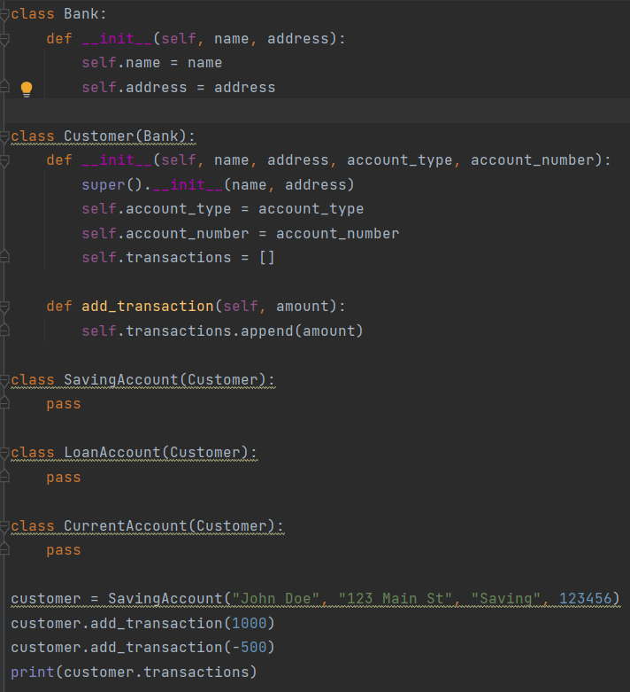

**Output-**

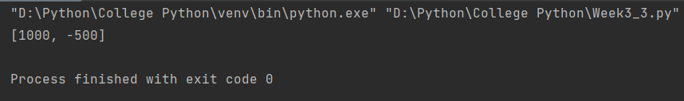

1. **In continuation with the above bank class. Now create scoreboard for the customers. Function name of score same in all three classes but scores the point according to the account type.**

**Saving account : Score 1 pt for each 2k credit and deduct .25 for each 2k debit, 1**

**point for consistent balance of 10k**

**Current account: Score 1 pt for each 2k credit 1 point for consistent balance of 10k,**

**reduce 1 pt for overdue more than 25k**

**Loan amount: Give 1 point for each on time repay and reduce 0.5 points for penalty payment.**

**Code-**

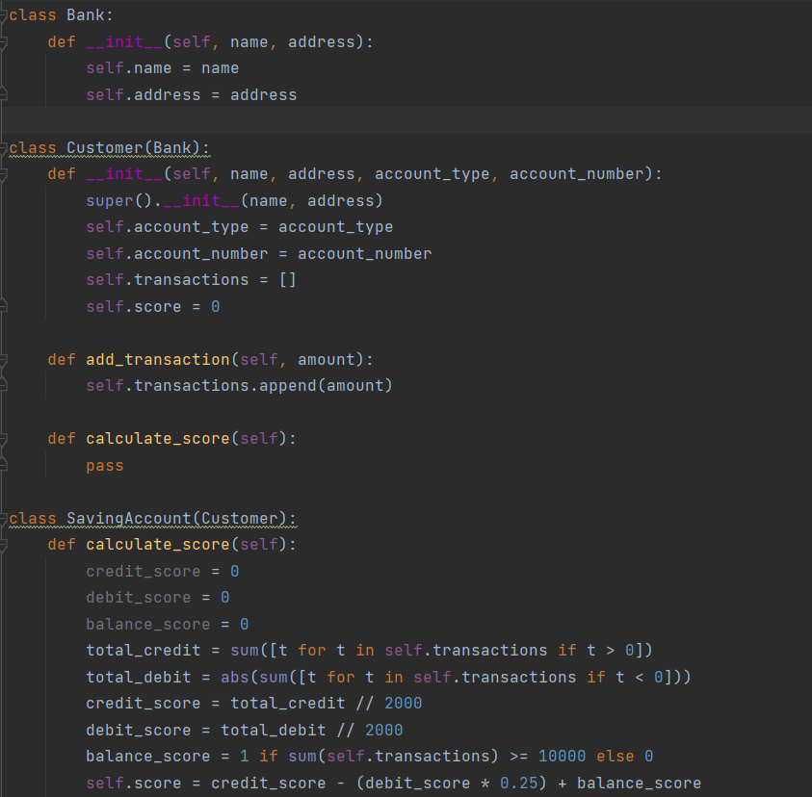

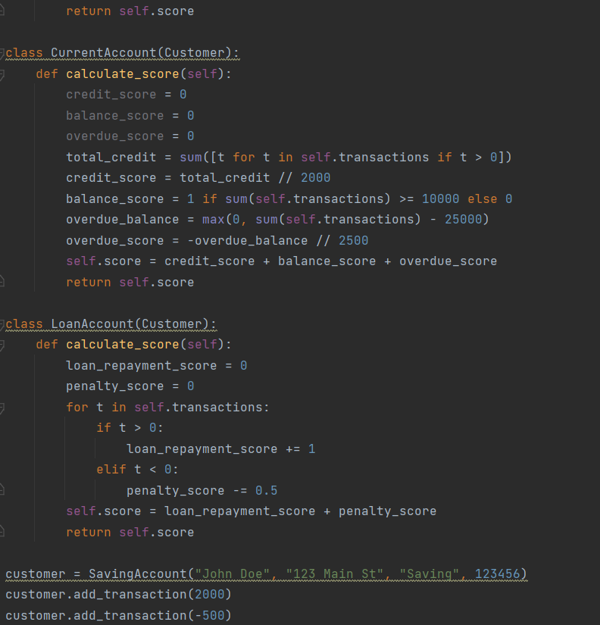

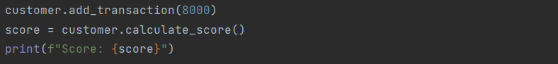

**Output-**

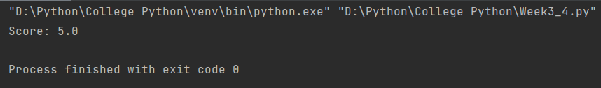

1. **Allow the customers to rate the services of the bank, give (display)customer a choice of service which they want to rate, and allow them to rate. Display the total score given by the particular customer and as the whole. (As an advancement take the score along with date display a chart with sum of scores on each period for each service).**

**Code-**

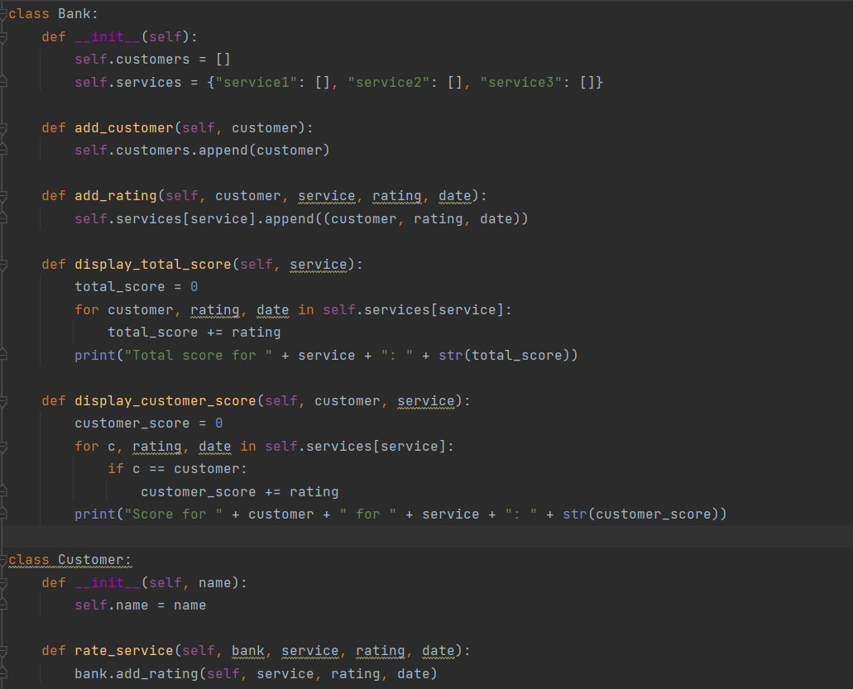

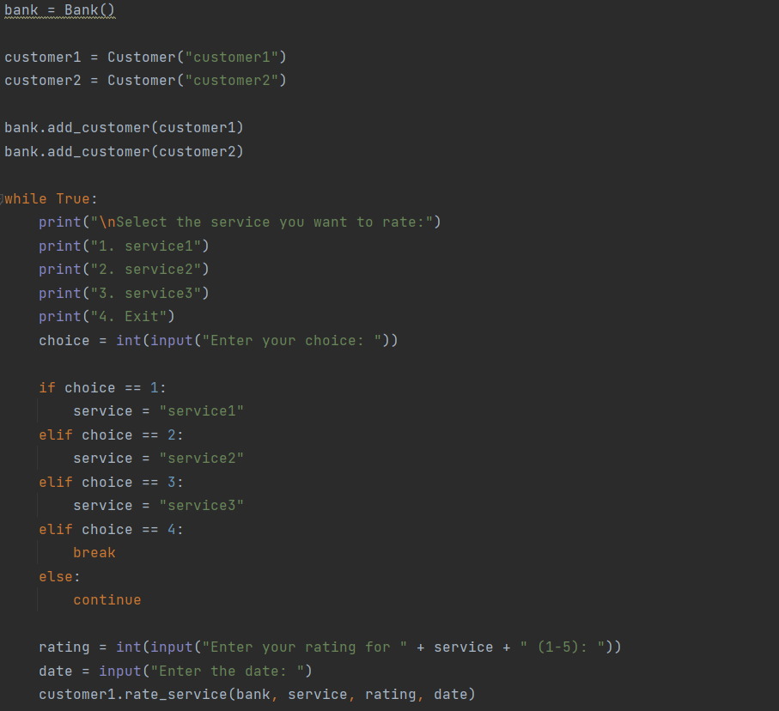



**Output-**

